**Depending on how cold this winter gets**

Contact us:

ibsghk@gmail.com

**-Outlook for the Europe energy**

Abstract:

* The electricity prices for EU main countries have doubled, with the peak exceeding 500 Euros/MWh, mainly due to the unique Marginal Costs Pricing Mechanism, lack of natural gas supply and the failure of other energies to fill the gap.
* We may conclude that the demand for natural gas is solid in the short-term. The price surge in natural gas is mainly a result of supply shortages. However, we believe that in the long-term the demand for energy will be structurally changed after the European Energy crisis. The Policy will be the main guidance in predicting the long-term demand for natural gas.
* Even if Germany's gas storage facilities were 100% full, they would only last two and a half months when Russian supplies were completely stopped. Unless households manage to cut gas consumption by at least 20%, avoiding emergencies amid possible rationing will be a challenge. Germany's progress on gas reserves reduces the risk of energy rationing, but that does not mean it is mitigated. The final scenario still depends on how much businesses and households reduce their energy consumption and how cold this winter gets.

**Content:**

Abstract: 1

Introduction: 4

1. Supply Side: The electricity price has been highly affected by the lack of supply in natural gas 4

1.1. The price of electricity is determined by Marginal Cost Pricing Mechanism 4

1.2. The lack of natural gas supply 6

1.3. The failure of other Energies to fill the gap 9

2. Energy Consumption 10

2.1. Energy consumption before Energy Crisis 12

2.2. Natural Gas price surge and demand analysis 16

3. Case Study: Germany 22

3.1. The supply side 22

3.2. The demand side 23

3.3. Conclusion 25

4. Forward looking 26

Introduction:

As a developed capital market, Europe has always been a leader in ESG development. However, since February 2022, affected by the Russian-Ukrainian war and the long-term lack of energy investment, European energy supply has fallen into a shortage and prices have soared. In the short-term, the energy crisis will disrupt the EU's carbon neutrality plan and make the EU pay for its over-reliance on imported natural gas; but in the long run, the EU will embrace new energy more quickly after the adjustment period.

To make a better judgment on the development of new energy in Europe and the future price trend of traditional energy ,we will discuss the shortage of traditional energy in Europe, the development status of new energy, and the compensation of traditional energy shortages.

# 1. Supply Side: The electricity price has been highly affected by the lack of supply in natural gas

## 1.1 The price of electricity is determined by Marginal-cost pricing mechanism

Entering 2022, the electricity price for Europe has been escalating a lot. As shown below, the electricity prices for EU main countries have doubled, with the peak exceeding 500 Euros/MWh, due to the unique Marginal Costs Pricing Mechanism, lack of natural gas supply and the failure of other energies to fill the gap.

*Figure: Electricity prices in the selected EU countries*

*Source: Statista*

The escalation of natural gas’s price drives the marginal cost up, lifting the electricity price, determined by Marginal-cost pricing mechanism. The European electricity market has always been priced at marginal cost, which is the price quoted by the last electricity supplier whose transactional electricity meets the load demand. The electricity of the generator set with the quotation higher than the marginal electricity price cannot be traded, and the bidding fails; the generator set with the quotation lower than the marginal electricity price does not settle the spot electricity according to the quotation and the electricity market, but settles according to the marginal electricity price of the system.

Gas-fired power plants used to be marginal suppliers of electricity, meaning that the cost of generating electricity from natural gas determined electricity prices in Europe, because natural gas power plants have the advantage of being able to scale up or down faster than other thermal power plants (e.g., nuclear, lignite, hard coal).

*Figure: German marginal power gen costs inclusive of emission allowances(Euros/MWh)*

*Source: Deutsche Bank, Bloomberg*

Therefore, once the price of natural gas rises, the cost of electricity will inevitably rise. As the price of natural gas continues to rise, so does the marginal cost price of natural gas power plants. Even if most of a country's electricity comes from clean energy generation, it has to pay high electricity prices.

## 1.2. The natural gas supply shortage

According to BP data, about 21% of the total electricity generation in the EU and the UK in 2021 came from natural gas, making it the third largest source of electricity generation in Europe after renewable energy (27%) and nuclear energy (24%).

*Figure: 2021 EU & UK electricity source*

*Source: BP, CICC Research*

*Figure: Worsening relation between Russia & EU’s Effect on Supply*

*Source: Bruegel*

The supply of natural gas from Russia has declined from about 2000MCM/week to ~500MCM/week since the Russia & Ukraine war. According to our estimation, this will bring about a 32 BCM deficit, accounting for ~11% of the current natural gas supply. As the EU uses more than 30% of the natural gas to produce electricity, the deficit would result in a significant difference.

*Figure: EU gas storage after heating season*

|  |  |  |  |
| --- | --- | --- | --- |
|  | Sep.2022 | 4Q22E | Until Mar.31.2023 |
| Gas in Storage |  |  |  |
| Max capacity(BCM) | 111 | 111 | 111 |
| Current values(BCM) | 99 | 99 | 99 |
| Estimated Target(%) | 90% | 90% | 90% |
| **Estimated values(BCM)** | **100** | **100** | **100** |
|  |  |  |  |
| **Gas import(BCM)** | **29.00** | **87.01** | **188.83** |
| *From: Russia* | 2.47 | 7.41 | 14.81 |
| *Norway* | 10.15 | 30.46 | 60.93 |
| *Algeria* | *3.00* | *9.01* | *18.01* |
| *LNG* | *12.13* | *36.39* | *95.08* |
| *Others* |  |  |  |
| **EU Production** |  |  | **60** |
|  |  |  |  |
| **Comsumption** |  |  | **-321** |
| **Values in Storage** |  |  | **27.93** |
| Storage Rate |  |  | 25.11% |
|  |  |  |  |
| North Stream Effect on Import: |  |  | 4.44% |
| North Stream Effect on Supply: |  |  | **2.40%** |
| Russia & Ukraine Effect on Supply: |  |  | **10.98%** |

*Source: Bruegel*

***Methodology:***

***We base on the operation indicators in September and historical data to predict the result in the coming heating season(Usually Nov-Mar, to simplify while the winter is estimated to be longer, we estimate the result from Oct-Mar for 6 months).***

***BCM = Billion Cubic Meters 十亿立方米, MCM = Million Cubic Meters 百万立方米***

**Capacity:** The capacity of gas storage is relatively fixed to current level.

**Estimated Target:** Currently 89.3%, the initial target was 80%, but for fear of energy deficit, we estimate the filling rate to exceed 90%, so we take it as 90%.

**Gas import:**

**Import from Russia:** We take the import value after the shutdown of North Stream 1 & 2, which is 526.3 MCM/week, equivalent to 188.83 BCM during the heating season.

**Import from LNG:** Estimated to reach 234.75 BCM/yr at the end of 2022, we just simply use CICC estimation.

**Others:** We take the value in September, and multiply it by 6.

**EU production:** EU Production in the heating season(Nov-Mar) is relatively constant, about 50 BCM, so we use 60 here.

**Consumption:** Consumption in the heating Season(Nov-Mar) is relatively constant at 267.5 BCM, and we multiply it by 6/5.

**Value in storage: =** Estimated values+Gas import+EU production-consumption, and the estimated terminal value in storage is **~28 BCM**, whose corresponding storage rate would be ~25% at the end of the heating season, much lower from 5-year average ~40 BCM.

1.3. The failure of other energy sources to fill the gap

**Coal:**

According to Wood Mackenzie statistics, about 11GW of coal power capacity in Europe as a whole has resumed production, accounting for about 1/10 of Europe's total coal power capacity. On the other hand, the utilization hours of coal power have also increased. The utilization hours of the 14 major European coal power producing countries according to our statistics have reached 2,380 hours in the first eight months of this year. It will reach 4,000 hours, a further increase from 3,716 hours in 2021 and 2,658 hours in 2020.

In the EU coal supply, imports account for a relatively high proportion. In 2021, the output of coal and lignite in the 27 EU countries will be about 330 million tons, the external import volume will be about 85 million tons, and the import dependence will be about 22%. In 1H2022, EU coal imports increased by 49% YoY, further increasing import dependence.

*Figure: EU coal Import and Production from 2017-2021*

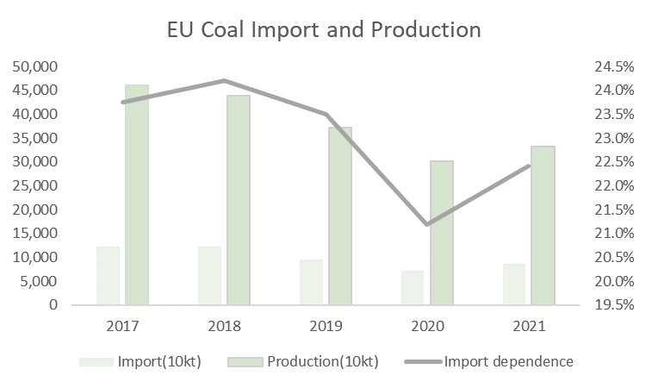

*Source: IEA*

However, 45% of the EU's annual coal imports come from Russia, with a total value of about 4 billion euros, the embargo on Russian coal will affect 10% of the total coal supply. Although coal can be imported from other countries and regions, the cost will rise, lifting the marginal cost of electricity.

**Other Energy**

The high temperature and severe drought in Europe this summer have had a serious impact on power production. Hydropower, nuclear power and solar power generation are not immune, exacerbating the shortage of supply in the European power market.

**Hydropower:** Continued high temperatures in Europe have led to increased evaporation from rivers, lakes and reservoirs, lower water levels and severe impacts on hydropower generation. In Italy, for example, hydropower accounts for 20% of the country's total electricity production, but the country's hydropower production has plummeted by 40% in the past 12 months.

**Nuclear power:** Statistics from a Norwegian energy consultancy show that in the first seven months of this year, Europe's hydropower generation fell by 20% compared with the same period last year, while nuclear power generation fell by 12%.

Maintenance work and technical problems at French nuclear power plants have reduced their generating capacity. According to media reports, out of France's 62 gigawatts of nuclear power capacity, only 25 gigawatts are currently available.

**Solar power:** On the other hand, hot weather is also not conducive to solar power generation. High temperature will cause the power loss of photovoltaic panels and shorten the service life. When the temperature exceeds 25 degrees Celsius, the power generation of photovoltaic panels will drop significantly.

# 2. Energy consumption

Key facts before reading this section:

* Out of total energy available, about 2/3 is consumed by end-users and about 1/3 is mainly lost during electricity generation and distribution or non-energy uses.
* There are two energy products, the primary and secondary energy products.

|  |  |
| --- | --- |
| **Primary Energy Products**  Ex.  Natural Gas  Crude Oil  Coal | **Direct Consumption**  Ex.  Natural gas for heating  Solar thermal for sanitary hot water |
| **Transformation:**  Ex.  Refineries, power plants, industrial process | **Secondary energy products**  Ex.  Electricity  Oil product  Coke used mostly in blast furnaces |

* Demands for energy include exports and final energy consumption.
* Gross available energy = Primary production + Recovered & Recycled products + Imports – Export + Stock changes
* Total final consumption (TFC) is the worldwide consumption of energy by end-users (whereas primary energy consumption (Eurostat) or total energy supply (IEA) is total energy demand and thus also includes what the energy sector uses itself and transformation and distribution losses). Final consumption=Direct consumption + secondary energy product consumption= Primary energy consumption (Primary energy products)- loss in distribution.

In this section, we care about the primary energy consumption which is determined by the demand of the households and plays an important role in maintaining the development of the economy.

2.1 Energy consumption before Energy Crisis

2.1.1 Primary and final energy consumption in Europe

*Figure:* *Primary and final energy consumption in the European Union from 2005-2021*

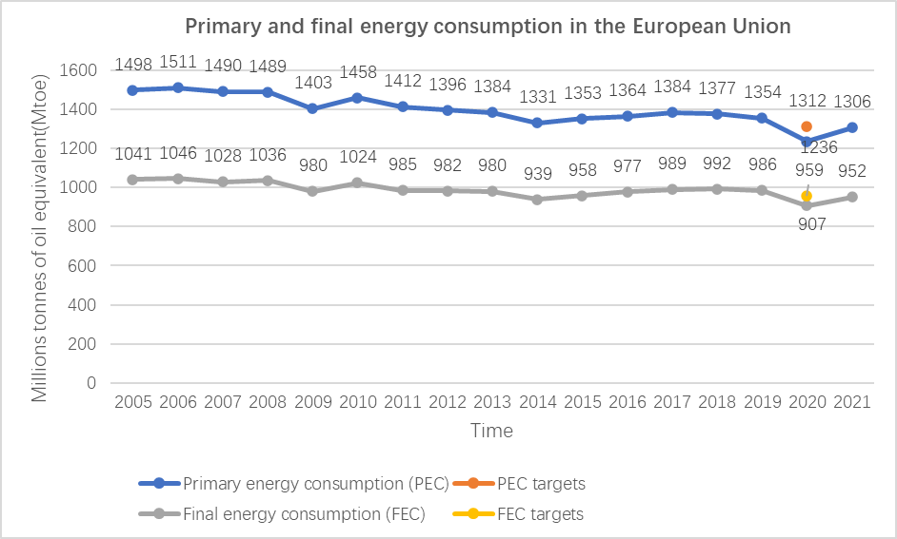

*Source: European Environment Agency*

*\** *1 Mtoe=11630000 MWh*

In 2020, the energy consumption in Europe decreased extraordinarily due to the Covid-19 Pandemic. The primary consumption increased about 5.7% but it is still below the pre-pandemic levels.

We can observe that the decrease in pandemic period is similar to the drop pattern in the Global Financial Crisis in 2009. The energy consumption is stable in the long-term. Some turning points are worth noticing. For example, in 2018, the EU's primary energy consumption decreased by 0.9% compared with 2017, following three consecutive years of increasing consumption. This decrease was caused by various factors, in particular energy efficiency improvements, an increase in the share of energy consumed from hydro, wind and solar photovoltaic (PV) power, the economic recession and changing climate conditions.

2.1.2 What kind of energy do people consume in Europe (primary consumption)?

**Key takeaways:**

Petroleum products have the largest share in the EU energy mix.

Between 1990 and 2020 the amount and share of solid fossil fuels in final energy consumption dropped significantly.

**2.1.2.1 Key trends in 2005-2017**

*Figure:* *Primary energy consumption by fuel type in EU28 from 2005-2017*

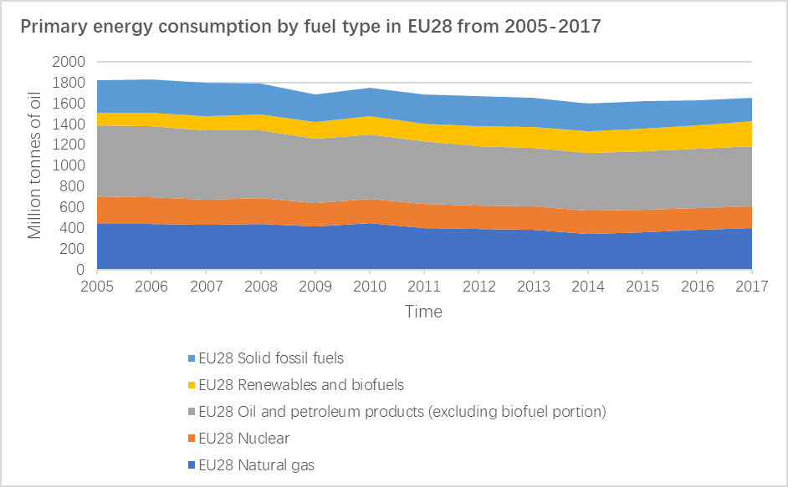

*Source: Eurostat*

The share of coal and lignite in EU primary energy consumption decreased from 18.0% in 2005 to 14.4% in 2017. The use of coal has decreased partly because of the increase in electricity generation from renewable sources, national policies and energy market developments.

The share of natural gas in EU primary energy consumption was 25.0% in 2005 and 24.4% in 2017.The absolute consumption of natural gas first decreased from 2005 to 2014 and increased from 2014 to 2017. Various factors have affected operations of gas-fired power plants, which ran continuously (base-load) in the past, but which now tend to operate more often during peak-load times, thereby reducing yearly operating hours. The use of natural gas is sensitive to the price of coal and other renewable energies.

**2.1.2.2 Primary consumption in EU27 by fuel type, 2019-2021**

*Figure:* *Primary energy consumption by fuel type in EU27 from 2019-2021*

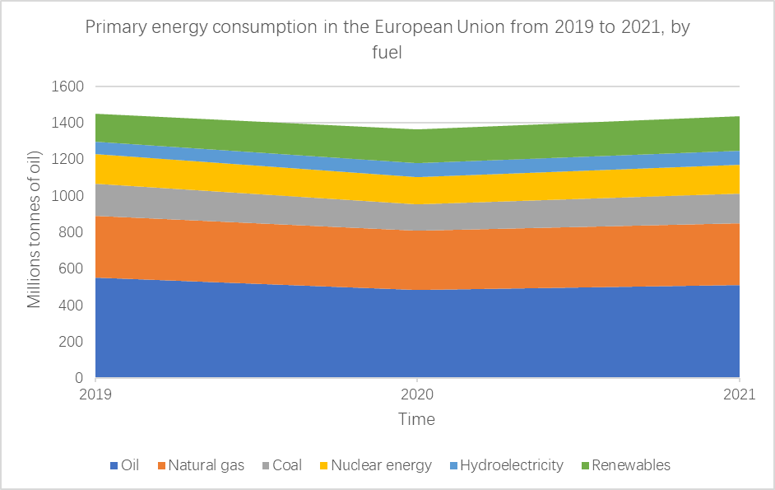

*Source: Statistica*

Although the absolute total amount of primary energy consumption in EU changed from 2019-2021 but the share of different fuel type does not encounter dramatical change.

2.1.3 Who are consuming energy in Europe?

*Figure: Final energy consumption in EU 1990-2020*

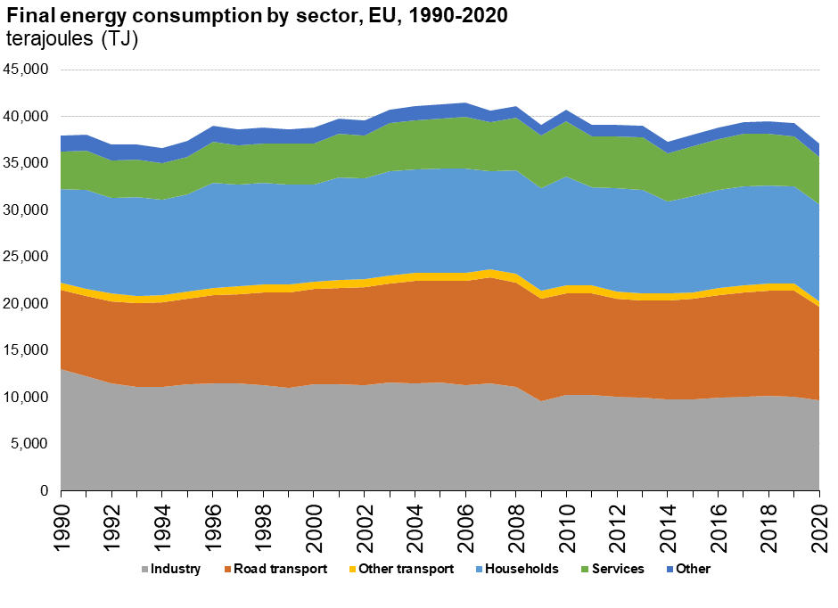

*Source: Eurostat*

The figure above shows us a rough picture of energy consumption by sector. In fact, different energy sector also consumes different sources of energy. It also differs geographically, because energy prices differ in different countries. For example, in the second half of 2021, Natural gas prices for household consumers, including taxes and levies, were highest in Sweden (EUR 19 per 100 kWh), Denmark (EUR 12 per 100 kWh), the Netherlands and Spain (both EUR 11 per 100 kWh), and lowest in Hungary (EUR 3 per 100 kWh), Croatia, Lithuania, Slovakia and Latvia (EUR 4 per 100 kWh each). The share of taxes and levies in gas price was highest in the Netherlands (58%) and lowest in Greece (6%). Natural gas prices for non-household consumers (excluding VAT and other recoverable taxes and levies) in the second semester of 2021 were highest in Finland (EUR 10 per 100 kWh), Sweden and Demark (both EUR 8 per 100 kWh), and lowest in Czechia, Slovakia, Belgium, Portugal and Spain (EUR 3 per 100 kWh each).

2.2 Natural Gas price surge and demand analysis

In the first half of 2022, we observed a dramatic price surge in natural gas.

*Figure: Development of natural gas prices for non-household consumers, EU, 2008-2022   
(€ per kWh)*

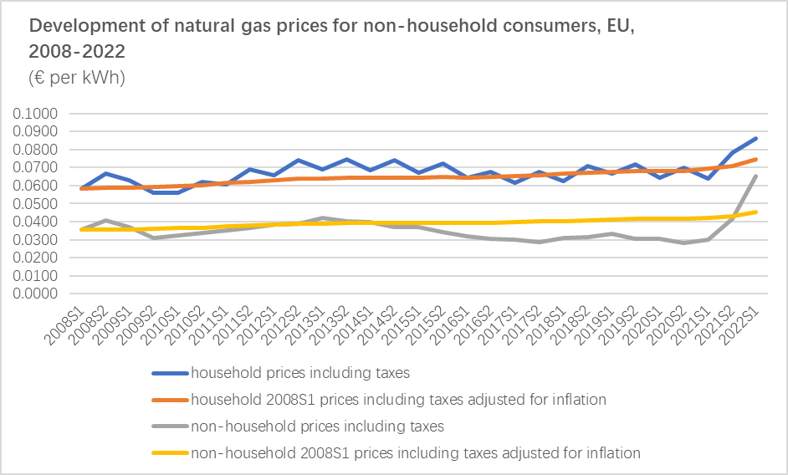

*Source: Eurostat*

Natural gas currently represents around a quarter of the EU's overall energy consumption. About 26% of that gas is used in the power generation sector (including in combined heat and power plants), and around 23% in industry. Most of the rest is used in the residential and services sectors, mainly for heat in buildings.

*Figure: EU Gas demand share of total, 2019*

*Source: Eurostat and Rhodium Group*

We narrow down our analysis to three sectors which respond to the price change of natural gas.

2.2.1 Natural gas demand descriptive analysis by sector

The residential sector accounts for most of EU gas demand (40%), followed by industry and gas use for power generation. Industry consumption has declined by 20% since 2000, whereas in the same period gas use for power generation has risen by 15%. These trends are due to the EU’s economic transition from industry to energy services and structural changes in the energy-intensive industry.

Industrial Sector

We assume that it is more sensitive to the natural gas price change and macroeconomic environment.

Household and Commercial Sector

We assume that it is more sensitive to temperatures, natural gas prices and energy regulations.

Electricity Production Sector

We assume that it is more sensitive to electricity demand. Natural gas is a substitution of fossil fuels and other renewable energy used to produce electricity.

2.2.2 Natural gas demand volume analysis

*Figure: Natural Gas Consumption in EU monthly 2017-2022*

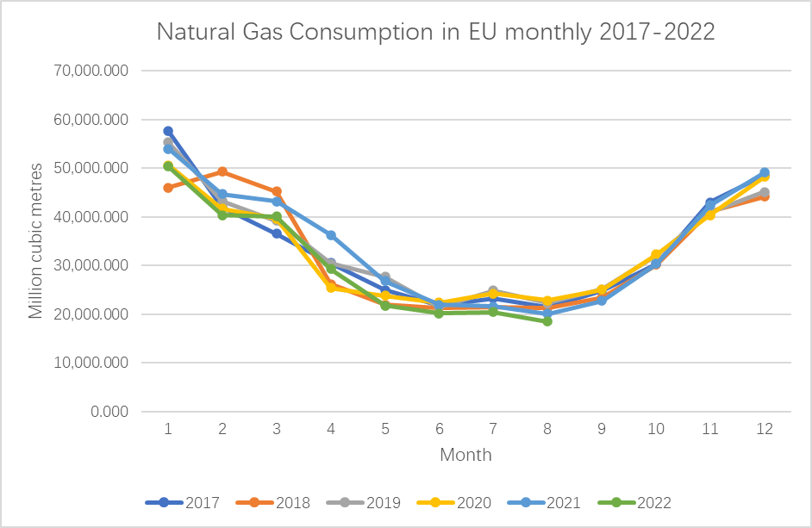

*Source: Eurostat*

We then run linear regression on the volumn demand of natural gas in the past five years.

*Figure:* *Linear Regression test for 2021*

*Source: Eurostat*

We observe that the volume demand of natural gas is highly seasonal. The demand for natural gas in 2022 has similar pattern as that of 2021 but with lower volume demand. The time sequence allows us to factor in the price’s impact to the demand in 2022. The demand for natural gas in 2022 is highly correlated with that of 2020. However, we don’t not observe price surge in natural gas in 2020. We might conclude that the price surge plays a similar role in decreasing the volume of natural gas demand as pandemic lockdown.

**2.2.2.1 The relation between natural gas demand volume and other factors**

The descriptive relation between natural gas demand and natural gas price

*Figure:* *Natural Gas Consumption and TTF Natural Gas Spot Price from 2017 to 2022*

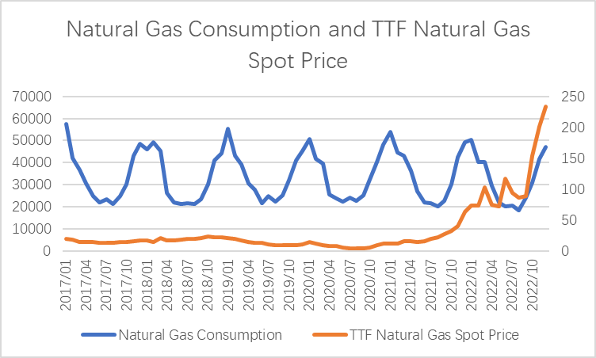

*Source: Eurostat, FactSet*

Price change has a slight effect on natural gas demand. We then calculate the elasticity of the natural gas demand in January and July seperately.

Elasticity analysis

|  |  |  |  |  |  |  |
| --- | --- | --- | --- | --- | --- | --- |
| *Table:* *Natural Gas demand elasticity January***Time** | **TTF Natural Gas Spot Price** | **Natural Gas Consumption** | **%Change in Price** | **%Change in Quantity** | **Elasticity** | **Interpretation** |
| 2021/01 | 11.85984 | 54016.16 | NA | NA | NA | NA |
| 2020/01 | 13.67913 | 50648.96 | 14.25% | -6.43% | 0.45 | inelastic |
| 2018/01 | 16.74486 | 46036.8 | 20.15% | -9.54% | 0.47 | inelastic |
| 2017/01 | 18.92266 | 57628.4 | 12.21% | 22.36% | 1.83 | elastic |
| 2019/01 | 21.18137 | 55296.08 | 11.26% | -4.13% | 0.37 | inelastic |
| 2022/01 | 72.84721 | 50319.22 | 109.89% | -9.42% | 0.09 | inelastic |

|  |  |  |  |  |  |  |
| --- | --- | --- | --- | --- | --- | --- |
| *Table:* *Natural Gas demand elasticity July***Time** | **TTF Natural Gas Spot Price** | **Natural Gas Consumption** | **%Change in Price** | **%Change in Quantity** | **Elasticity** | **Interpretation** |
| 2020/07 | 4.187866 | 24244.1 |  |  |  |  |
| 2019/07 | 10.18496 | 24848.33 | 83.45% | 2.46% | 0.03 | inelastic |
| 2017/07 | 13.19869 | 23263 | 25.78% | -6.59% | 0.26 | inelastic |
| 2018/07 | 18.85779 | 21445.3 | 35.31% | -8.13% | 0.23 | inelastic |
| 2021/07 | 19.16279 | 21612.11 | 1.60% | 0.77% | 0.48 | inelastic |
| 2022/07 | 94.02672 | 20476.39 | 132.28% | -5.40% | 0.04 | inelastic |

We can conclude that the demand for natural gas is inelastic.

Other Factors:

As mentioned above, we observe a similar pattern of natural gas consumption in 2020 and 2022 while there is no dramatic price surge in 2020. We may conclude that the demand for natural gas is solid in the short-term. The price surge in natural gas is mainly a result of supply shortages.

However, we do believe that in the long-term the demand for energy will be structurally changed after European Energy crisis. The Policy will be the main guidance in predicting the long-term demand for natural gas.

*Table: REPowerEU Plan*

|  |  |
| --- | --- |
| Pillar | Specific Measures |
| Reducing energy consumption | In the near-term, the Commission envisages a 5% reduction in gas and oil consumption from a new ‘Playing My Part’ public information campaign, aimed at households.  Over the medium term, regulatory measures to improve the energy efficiency of buildings and to enhance product sustainability are expected to lead to further savings. Concretely, the EC proposes to increase the planned energy demand reduction by 2030 (relative to 2020) in the energy efficiency directive from 9 to 13% |
| Diversifying supplies | A new EU Energy Platform has been established to support voluntary joint purchases of gas, LNG, and hydrogen. Operationally, the platform primarily supports information sharing between members states.  The EC is considering a voluntary ‘joint purchasing mechanism’ to negotiate gas import contracts on behalf of multiple countries. |
| Accelerating the green transition | Solar is a key pillar of the more ambitious renewable roll-out, with the EC aiming to double installed capacity by 2025 from today and again by 2030. Likewise, wind energy rollout is to be accelerated by significantly streamlining permitting.  Accelerate the heat pump rollout, with an accompanying push to increase domestic European production networks.  An ambitious target for green hydrogen production and imports of a total of 20 million tons by 2030 was set. This will require investments in the order of 25-50 billion Euros. Detailed infrastructure needs will be mapped by March 2023.  Biomethane gas production is planned to ramp up to 35BCM, at a cost of 37 billion Euros by 2030.  National permitting procedures are to be significantly facilitated in line with guidance provided by the EC, |
| Improved connectivity within Europe | Ongoing infrastructure improvements (e.g., the gas interconnector between Poland and Lithuania and the Baltic pipeline between Denmark and Poland) will add transmission capacity in 2022. Recently acquired floating LNG terminals in Germany and Finland will ease infrastructure bottlenecks during 2023.  Additional priority projects at a cost of €10bn were identified (e.g. capacity for flows from France and Belgium into Germany) which would remove internal infrastructure bottlenecks over the next few years.  Investment is also planned in the electrical power grid (€39bn), consistent with a greater reliance on renewable power generation |
| Emergency preparedness | To prepare for a possible disruption scenarios,the following steps are proposed: (i) swift adoption of the proposed storage regulation (mandating minimum 80% storage levels by October 1), (ii) short-term energy savings efforts, (iii) member states update contingency plans; (iv) Convince transmission systems operators (TSOs) to fast-track technical measures which can increase the reverse flow capacities from west to east by next winter and (v) conclude outstanding bilateral solidarity agreements |

*Source: IMF*

# 3. Case Study: Germany

The logic behind the "cancellation" of carbon neutrality plans in Britain, Denmark and the UK? Take Germany, for example.

The German parliamentary Committee on Climate Protection and Energy abandoned the "greenhouse gas emission neutrality by 2035" target and replaced it with "once the coal phase-out is completed and greenhouse gas neutrality in the electricity supply is achieved, the further expansion of renewable energy will be market-driven".

3.1. Supply side:

a) Electricity supply is short; Energy alternatives are urgently needed; Russia cut of Natural gas supply due to Russo-Ukrainian War

In recent years, EU has gradually shrunk its natural gas production, while increasing import of Russian gas. Until the conflict broke out, Gazprom accounted for 40% of the EU's gas consumption. Germany, the most dependent on Gazprom among EU members had took the hardest hit, with 55%-60% of its Natural gas supplied by Gazprom.

We will mainly discuss Germany, as Germany is the largest Gazprom importing member of EU and was the most influenced.

In total, Germany's power balance had been tight in 2022, with monthly energy output barely covering the consumption. The soaring cost of fossil fuel, the disadvantaging climate change causing limited energy generated by renewable energy like wind, directly applying pressure on electricity production. With the damage to Nord Stream 1, Gazprom's imports is not within the foreseeable future.

ii. Gazprom is the source of 15-20% German electricity

In July, for example, hydropower accounted for about 5%, nuclear power for about 7.17%, fossil fuel power for about 41.20%, and renewable energy for about 44.8%. Germany’s dominant energy sources are renewable energy and fossil fuel energy generation.

According to the 2021 data of German energy consumption, natural gas from Gazprom accounted for 55% of its total consumption.

iii. Estimated gaps

According to the calculation of the total shutdown of Gazprom, there will be a total power shortfall of 8.25%-12% in Germany at present. In July this year, the member states of the European Union agreed to "voluntarily cut" the gas consumption by 15% from August this year to March next year to cope with the energy shortage. Deutsche's models show that if Germany were to cut demand by 20%, it could survive the winter even in the event of a total disruption to Gazprom, at the cost of using up most of its current gas storage before the end of the heating season.

b) Fossil energy substitution

i. Natural gas (non-Russian)

Experts say security of supply is guaranteed. The situation was "tense but stable". Gas storage tanks are 96% full, and storage levels are higher than in 2015, 2017, 2018 and 2021.

ii. LND (Liquefied Natural gas)

The German government leases five floating LNG Storage tank to import liquefied gas. Only three will be available this winter. The other two will be available in early 2023/24.

iii. The coal

iv. In the classified government documents, experts assessed the security of coal supplies as "tight but manageable". Despite the current coal embargo on Russia, there is still enough coal to keep fuel flowing. The document also noted that new coal plants in southern Germany would not be filled "until winter." The document also shows the power structure in chart form for calendar weeks 38-41 (from September 19 to October 16). 7.2% of electricity comes from nuclear power and 21.7% from lignite. Without these two sources of electricity, Germany may face difficulties.

c) Clean energy

i. Nuclear energy

Currently, the withdrawal of nuclear programs by original plan was suspended but not cancelled. The three nuclear reactors, Isar 2, Emsland and Neckarwestheim 2, will remain connected to the grid until April 2023.

ii. Renewable energy

Renewable energy provided nearly half of Germany's electricity in the first six months of 2022, according to preliminary data released by energy industry association BDEW and research institute ZSW. Solar panels, wind turbines, biogas plants and other installations met 49% of electricity demand, up 6%age points from the same period last year. Wind turbines were the most important renewable energy source, with their share increasing from 17% to 21% and solar panels from 10% to 12%, while the country's electricity consumption fell slightly by 2 billion KWH to 281 billion KWH. In total, renewables generate 139 billion KWH of electricity and export 17 billion KWH.

3.2. The demand side

a) German Government policy

i. Aggregate demand adjustment

With gas storage already at 95% of its maximum capacity, German households and businesses are still required by the energy regulator to cut their energy consumption by at least 20%. Even if Germany's gas storage facilities were fully filled, it would account for only slightly over a fifth of the country's gas consumption in 2021, Reuters reported. There is no guarantee that Europe will survive the winter at current levels of gas storage

ii. The pricing adjustment

Germany's ruling coalition agreed on September 29 to impose emergency price caps on the domestic gas market and cut sales taxes to ease the economic pressure on consumers and businesses from soaring gas prices. Up to €200bn will be spent on subsidies by the spring of next year to compensate energy companies for the price cuts.

In the same classified ministry document mentioned before, the German government plans to impose a cap on electricity prices for households and industry to ease the impact of soaring energy costs.

To help finance the cap and pay for stabilizing the grid, Berlin is considering cutting profits for power companies, according to the documents. Households and companies coping with soaring energy prices will be financed by a 200-billion-euro ($196 billion) subsidies.

As part of the plan, the government plans to deduct 90% of the electricity companies’ earnings above the cost of production.

3.3. Conclusion

Even if Germany's gas storage facilities were 100% full, they would only last two and a half months when Russian supplies were completely stopped. Unless households manage to cut gas consumption by at least 20%, avoiding emergencies amid possible rationing will be a challenge. Germany accounts for about a quarter of the European Union's gas storage capacity. Data show that the total capacity of gas storage facilities in Germany is around 23 billion cubic meters, just over a fifth of the 100 billion cubic meters of gas used in the country in 2021. German gas stocks could run out as early as March or April if temperatures remain normal, given that Russia has already cut supplies.

Germany's progress on gas reserves reduces the risk of energy rationing, but that does not mean it is mitigated. The final scenario still depends on how much businesses and households reduce their energy consumption and how cold this winter gets.

# 4. Forward looking

After the pressure on the demand side is relieved, further consumption of the accumulated inventory, rather than continuing to import high-priced LNG spot, or a possible path for the European gas market to achieve equilibrium. Therefore, on the whole, we judge that the European natural gas inventory is still likely to face super-seasonal consumption this winter, and the path of low inventory may be unavoidable, **so the European gas & electricity price would still under pressure until early 2023, when the heating season is coming to an end**.